**Sprint 1 Plan Template - CMPS 115 – Software Methodology**

At the end of your team's sprint planning meeting, the team needs to turn in a sprint plan. This document needs to be typewritten (or the team needs to use a web-based agile planning tool and provide the TA/tutor access to the tool to view the project) and have the following elements:

∙ **Heading:** Document name ("Sprint {number} Plan"), product name, team name, sprint completion date, revision number & revision date.

Product Name: HungrySlug

Team Name: Team HungrySlug

Sprint completion date: 04/09/2024

Revision number: 1.1

Revision date: 04/12/2024

High Level Goal:

Display available foods at dining halls and allow users to create accounts.

∙ **Goal:** Short, 1-2 sentence description of the high-level goal(s) for the sprint. ∙ **Task listing, organized by user story:** This section lists the user stories, in priority order from most important (top) to least important (bottom). Within each user story, there needs to be a list of tasks required to implement the user story, along with the time estimate for each tasks (preferably less than or equal to 6 ideal hours). This should look like:

*User story 1 ("As a {user role}, I want {goal} [so that {reason}]")*

*Task 1 description (time estimate for task 1)*

*Task 2 description (time estimate for task 2)*

*...*

*Task N description (time estimate for task N of user story 1)*

*Total for user story 1: XX hours*

*User story 2*

*Task 1 description (time estimate for task 1)*

*Task 2 description (time estimate for task 2)*

*...*

*Task N description (time estimate for task N of user story 2)*

*Total for user story 2: YY hours*

*...*

*User story M*

*Task 1 description (time estimate for task 1)*

*Task 2 description (time estimate for task 2)*

*...*

*Task N description (time estimate for task N of user story M)*

*Total for user story M: ZZ hours*

As a student, I want to be able to see the food that could be available at the dining hall so that I know what food I can get if I go to a specific one. [2]

1. Create a barebone website that can be built upon for future features. I think using **React** will be a good idea. Also with a GitHub page. (60 mins)
2. Connect a **Python** backend or some other language to the website. (Flask, Django) (30 mins)
3. Create some form of database to store data. This could be **Firebase**. (30 mins)
4. Be able to get the data raw from the ucsc dining hall website and store the data in classes related to dining hall and meal time. (45 mins)
5. Convert class data in **Python** into **Firebase** database storage. (30 mins)
6. Be able to fetch data from **Firebase** and make them back into class data. (20 mins)
7. Attempt to create backend task that is running at all times and updates the firebase database with new changes to the menu
8. Implement a **CSS** framework to make things look nice (Tailwind CSS, Bulma) (5 mins)
9. Create a table to display foods to users. (20 mins)
10. Create a way to select a dining hall. (10 mins)
11. Check the time of day to hide and show certain meals to users. (10 mins)
12. Initial navigational aspects to the website for current and future pages. Navigation bar with blank pages. (20 mins)

Total for user story 1: **5 hours** minimum

As a user, I want to be able to sign in to the platform, so I can keep track of what my preferences are. [2]

13. Create a means of rating a dining hall meal on the backend. (30 mins)

14. Create a sign in page or login page. (60 mins)

15. Use **Firebase** to keep track of all users that use the website. (60 mins)

16. Create a user profiles page that displays current known information about the user. (30 mins)

17. Create a friends system and display who your friends are. (60 mins)

Total for user story 2: **4.5 hours** minimum

∙ **Team roles:** Give a listing of all team members. Next to the team member, list their role(s) for this sprint. Assign each person to at least one role (for example, this role might be "Developer"). This looks like:

Ian (Product Owner, Developer)

Akshat (Scrum Master, Developer)

Anya (Developer)

Akhil (Developer)

Noah (Developer)

*Team member 1: role 1 {, role 2, role 3}*

*Team member 2: role 1 {, role 2, role 3}*

*...*

*Team member N: role 1 {, role 2, role 3}*

∙ **Initial task assignment:** A listing of each team member, with their first user story and task assignment. This should look like:

*Team member 1: user story, initial task*

*Team member 2: user story, initial task*

*...*

*Team member N: user story, initial task*

Ian: US1: T1, T4, T5, T6, T8

Akshat: T3, T5, T11, T14

Anya: T6, T12, T15

Akhil: US1:T2, T9, US2: T16

Noah: US1: T10, T13, T17

∙ **Initial burnup chart:** A graph giving the initial burnup chart for this sprint and is labeled as such with sprint number and project name and is located in the lab.

∙ **Initial scrum board:** Also known as a task board, the scrum board is a physical board and labeled as such with sprint number and project name and located in the lab. This board has four columns, titled user stories, tasks not started, tasks in progress, and tasks completed. Index cards or post-it notes representing the user stories and the tasks for this sprint should be placed in the user stories, tasks not started, and tasks in progress columns. Tasks associated with a user story should be placed in the same row as the user story.

On GitHub

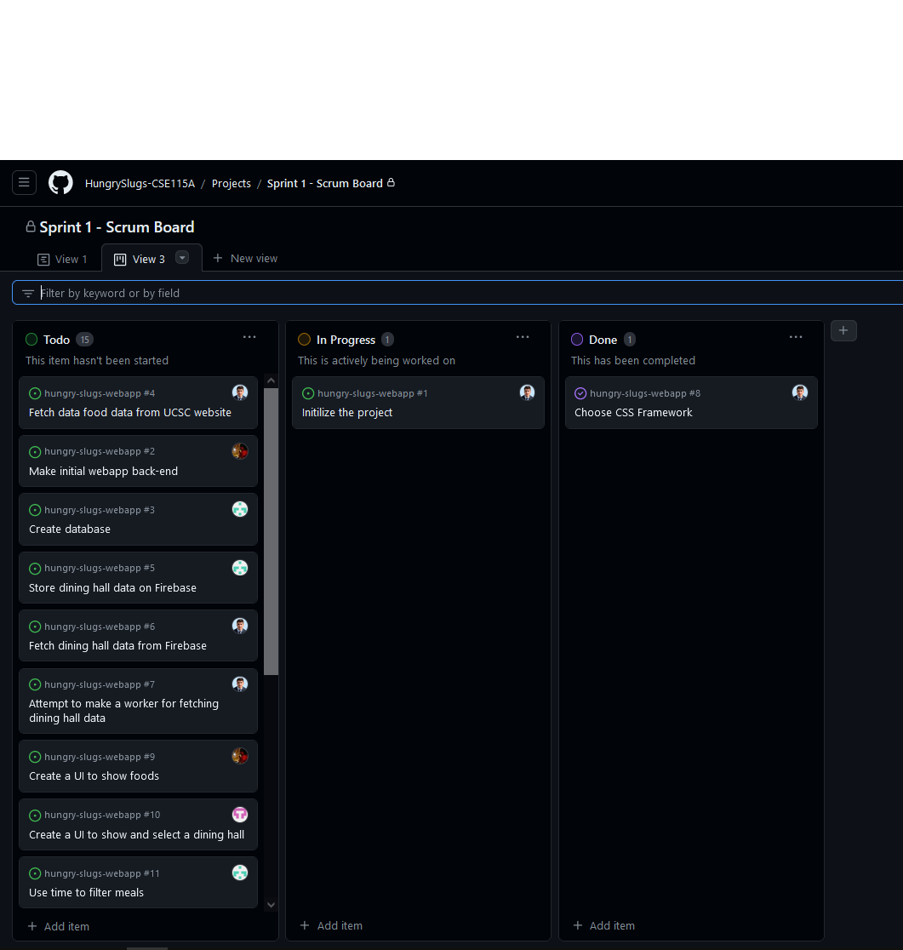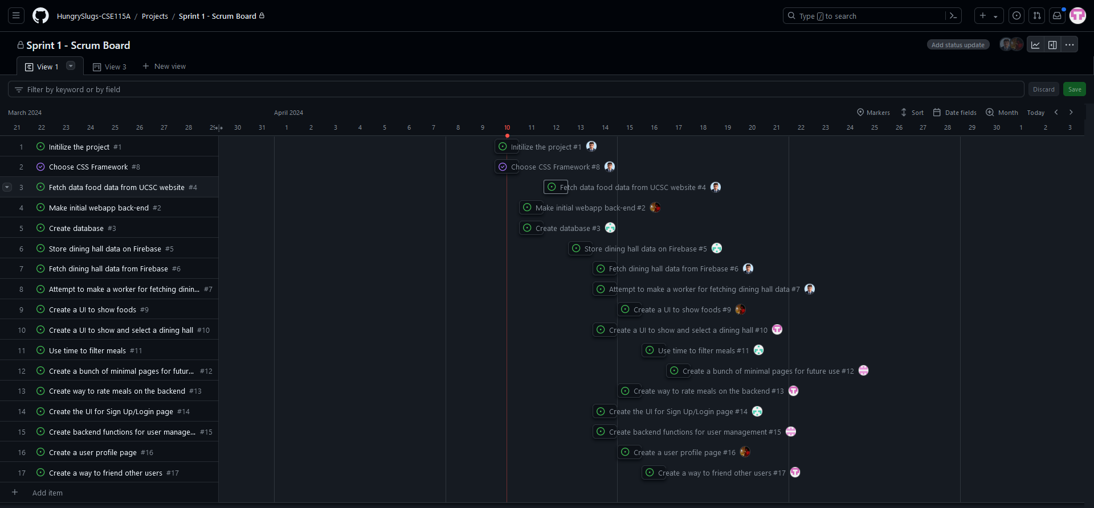

∙ **Scrum times:** List at least the three days and times during the week when your team will meet and conduct Scrum meetings. Also, indicate which of these meetings will have the TA/tutor visit as arranged with the TA/tutor. It is expected the TA/tutor will visit during the Scrum meeting during your lab time.

1. Mondays 11:00am – 12:00pm, Zoom with TA
2. Wednesdays 9:10am - 9:25am, with team
3. Fridays 9:10am - 9:25am, with team

Note that if the team ended up modifying its release plan during sprint planning, submit an updated release plan document also with the sprint plan.

Last modified: 10/15/13 adapted from materials for cmps171